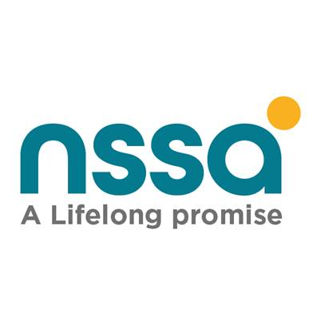

LIFE CERTIFICATE
Selous Avenue/Sam Nujoma Street Tel: Harare:0242 799030-44 Bulawayo: 0292 71013/4,
P. O Box CY 1418 Causeway Gweru: 0542 222379 Mutare: 02020 63294
HARARE Masvingo: 0392 264188 Chinhoyi: 06721 24140-9

YEAR…………………...
Tick Appropriate Box
Pension& Other Benefits Scheme Accident Prevention & Worker’s Compensation Scheme ___________________________________________________________________________________________________________________________________________________________

NB: This life certificate must be completed in full and accompanied by a valid copy of your National ID/valid Passport and birth certificates for minor children. Failure to complete the Life Certificate within 3 Months will result in the suspension of the Pension payment which can only be resumed on receipt of the Life Certificate by the nearest NSSA Office. Please note, submitting false information can render you liable to prosecution.
- Details of Contributor/Worker.
Contributor/Worker’s Name…………….…………………………………………………………………..…ID No.……...................................Pension/Social Security No………………………..
Physical Address……………………………………………………………………………………………….ContactAddress……………………………………………………………………….
Email Address…………………………………………………………………………………………………. Phone number/s (1)………………………………………(2)……………………….
Marital Status:(Single/Married/Divorced/Widowed) ……………………………….........................................If Married Name of Spouse…………………………………………………………..
ID No…………………………………………………Date of Marriage…../……/…………………………...Contact Number………………………………………………………………………
Are you Currently Employed…… If Yes Name and Address of Employer……………………………………………………………………………………………………………………………..
- To be completed by Widow/wer/Dependant/Parent.
Widow/wer/Dependant/Parent’s Name……………………………………………………… ID No.……………………………….... Pension/Social Security No.……………………………….
Physical Address………………………………………………………………….…………………………….Contact Address……………………………………………………………………..
Email Address………………………………………………………………………………………………….Contact Number/s……………………………………………………………………
I have remarried and my present husband/wife is………………………………………………………………ID No. ………………………………………………………………………………
Date of remarriage………………………………………………………………………………………………………………………………………………………………………………………
I certify that I last received my pension on Month ………………………………………………………….Year…………………………………………………..................................................
NB: (If you have not received your pension for more than 1 year, please attach a current Bank Statement) PLEASE TURNOVER

- To be completed by Guardian / Child.
Guardian’s Name………………………………………………………………………………… ID No…….……………………………….... Pension/Social Security No.…………………………………………………
Physical Address………………………………………………………………….………………………………….Contact Address ………………………………………………………………………………………....
Email…………………………………………………………………………………………………………………Contact Number/s………………………………………………………………………………………..

Child’s Full Name | Date of Birth | Child ID Number | Name of School/College being attended | School Contact details (Physical Address, Phone numbers, e-mail) | Date when child left School/College | Is Child Disabled | Is Child Married
If space provided is not enough, please use and attach a separate sheet of paper

________________________
Signature/Thumb Print
NB: This portion to be certified by a NSSA Official.

I………………………………………………………………………………. certify that …………………………………………………………………………..has signed the above in my presence and that, to the best of my knowledge and belief, the information given is correct.

Signature…………………………………………………………………..Designation…………………………………………………………. ……………………Date Stamp

