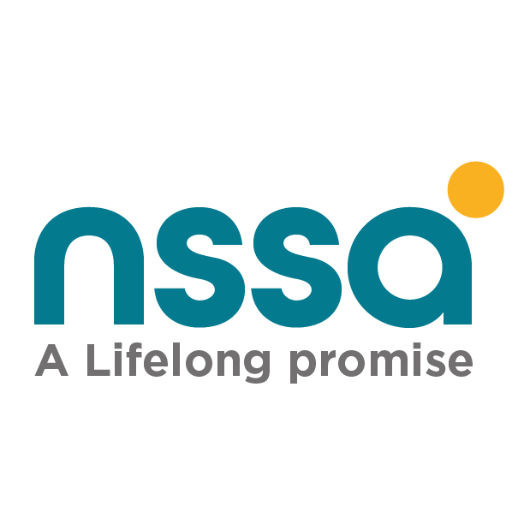
NSSA COMPLIANCE QUESTIONNAIRE
FOR EMBASSIES, INTERNATIONAL ORGANISATIONS AND CONSULATES

Place a tick in the appropriate box or fill in the space provided.
SECTION A NSSA EMPLOYER & EMPLOYEE REGISTRATION STATUS CONFIRMATION
Institution Details
1 | Name of Institution
2 | Postal Address
3 | Physical Address
4 | Contact Phone Number(s)
5 | E-mail Address(es)
6 | Employer Representative

Registration Status
- Does your institution employ Zimbabwean nationals? Yes No

- Is your institution Registered with NSSA? Yes No
  - If YES, please provide Social Security Registration
(SSR) Number
(NSSA will send current employee list on record to enable the Embassy/ International Organisation/Consulate to update same and revert through our electronic channels and/or NSSA Portal.)

2.2 If NOT Please download P2/3 forms from www.nssa.org.zw/downloads/, and send the completed copy to hrereturns@nssa.org.zw for registration. Alternatively, you may register both the institution and all local employees on the NSSA Self Service Portal through the following link: https://selfservice.nssa.org.zw/Identity/Account/Login?%2FHome%2FIndex=%2F

SECTION B: - FOR REGISTERED EMBASSIES/ INTERNATIONAL ORGANISATIONS AND CONSULATES
INFORMATION REQUIRED FOR EMPLOYER INSPECTION/ACCOUNT RECONCILIATION
- Has your account been inspected before? Yes No
  - If yes, please indicate the last year and month inspected

  - Provide payroll summaries showing NSSA Pensions and Other Benefits Scheme (POBS) and Accident Prevention and Workers Compensation Scheme (APWCS) Insurable earnings and Total Basic salaries respectively as well as deductions per each month for the period to be inspected since the last inspection.

  - Provide monthly return P4 form for each month for the period to be inspected since the last inspection. If never inspected submit from January 2017. (Refer to the P4 specifications and P4 template on www.nssa.org.zw/downloads/).
  - Please provide proof of payments in the form of NSSA receipts/RTGS copies for the period to be inspected.
- If never inspected, please provide all the above requested documentation from date of commencement/ engagement of Zimbabwean Nationals.

SECTION C: EMPLOYER OBLIGATIONS ON A MONTHLY BASIS (refer to NSSA Employer’s Guide for further guidance www.nssa.org.zw/downloads/)

NSSA legislation requires all employers of labour to:
- Submit a duly completed form P 2/3 to register their businesses and employees with NSSA within 30 days of employing labour.
- Submit a completed form P4C to deregister any employees who cease to be employed within 30days of such cessation
- Deduct Pensions and Other Benefits Scheme (POBS) contributions from employees on every payroll run and add an equal employer portion of the Pensions and Other Benefits Scheme (POBS) and remit to NSSA by the 10th of the following month.
- Compute and Remit premiums in respect of the Accident Prevention and Workers Compensation Scheme (APWCS) using the applicable rate for their line of trade/industry. The APWC code for Embassies/International Organisations/Consulates is 5400 and the rates for each financial year are as outlined in the document APWC INDUSTRIAL CODES AND RATES found on www.nssa.org.zw/downloads/
- Submit P4 forms (monthly return) by the 16th of the following month.
- Send proof of payment to NSSA accompanied by a P4A remittance form for receipting soon after payment.

Employer Representative Name: ______________________ Designation: _______________

Signature: _______________________ Date: _______________________

Please complete this questionnaire and send back with requested supporting documents to headofficeccc@nssa.org.zw AND copy to hrereturns@nssa.org.zw

